create user sumanth identified by sumanth123;

grant dba to sumanth;

create table person(

driver_id char(10),

Name char(20),

address char(30)

);

create table car(

reg_num char(10),

model char(15),

year int

);

create table owns(

drive_id char(10),

reg_num char(10)

);

create table accident(

report_num int,

accident_date char(15),

location char(10)

);

create table participated(

driver_id char(10),

reg_num char(10),

report_num int,

damage_amount int,

primary key(driver_id)

);

/**desc person;

desc car;

desc accident;

desc participated;**/

alter table person

add primary key(driver_id);

alter table car

add primary key(reg_num);

alter table owns

add constraint pk_owns primary key(drive_id, reg_num);

ALTER TABLE owns

ADD CONSTRAINT fk1_owns

FOREIGN KEY (drive_id)

REFERENCES person(driver_id);

ALTER TABLE owns

ADD CONSTRAINT fk2_owns

FOREIGN KEY (reg_num)

REFERENCES car(reg_num);

alter table accident

add primary key(report_num);

alter table participated

add constraint pk_participated primary key(driver_id, reg_num, report_num);

ALTER TABLE participated

ADD CONSTRAINT fk1_participated

FOREIGN KEY (driver_id)

REFERENCES person(driver_id);

ALTER TABLE participated

ADD CONSTRAINT fk2_participated

FOREIGN KEY (reg_num)

REFERENCES car(reg_num);

ALTER TABLE participated

ADD CONSTRAINT fk3_participated

FOREIGN KEY (report_num)

REFERENCES accident(report_num);

-- Person

insert into person values('&driver_id','&Name','&address');

commit;

select * from person;

--delete from person where Name = 'Richard';

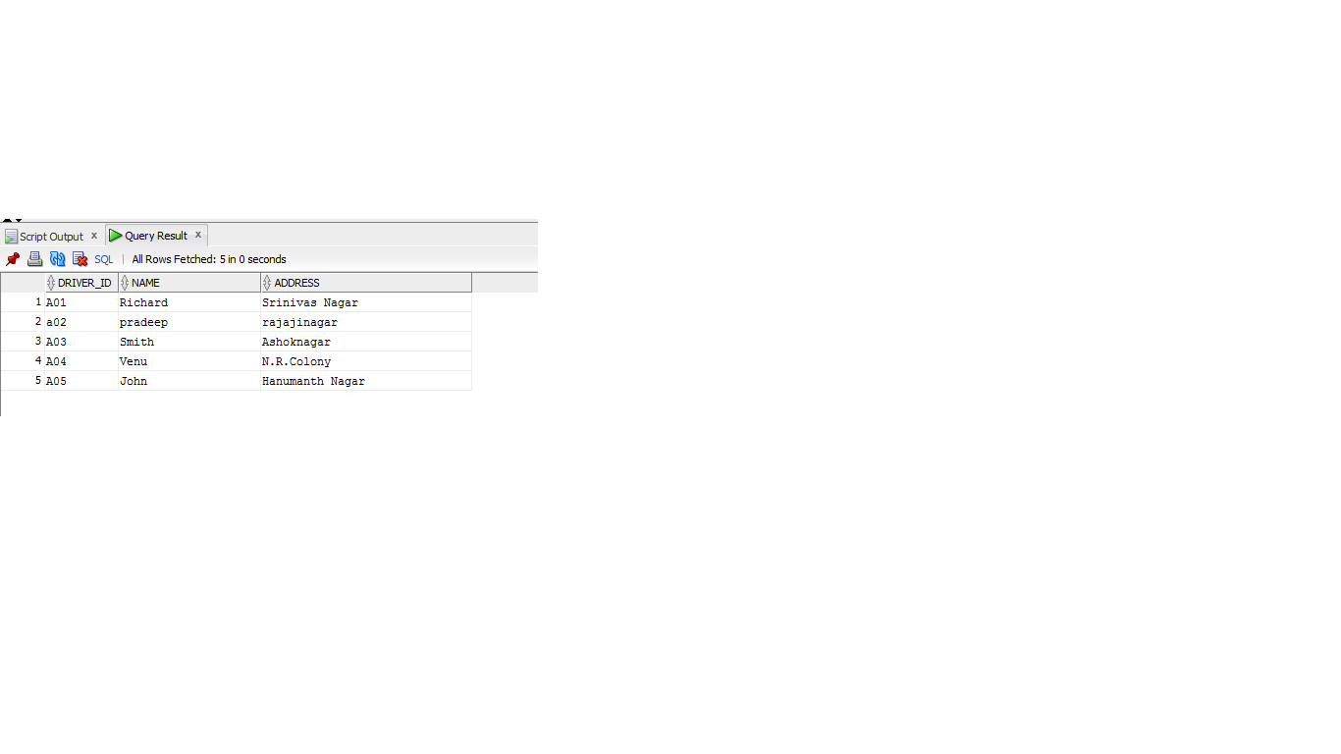

-- Car

insert into car values('&reg_num','&model', &year);

commit;

select * from car;

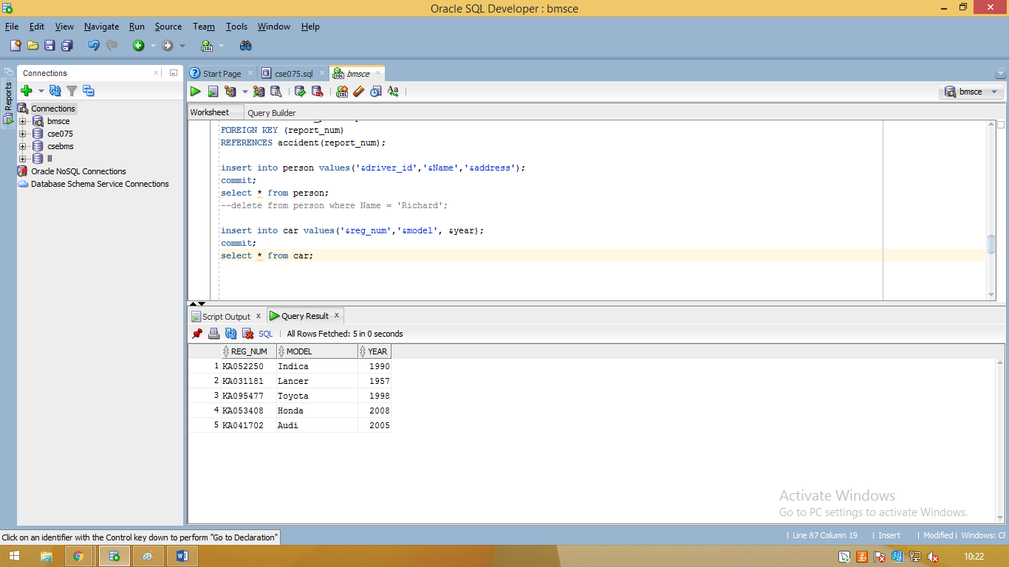

-- ACCIDENT

insert into accident values(&report_num,'&accident_date','&location');

commit;

select * from accident;

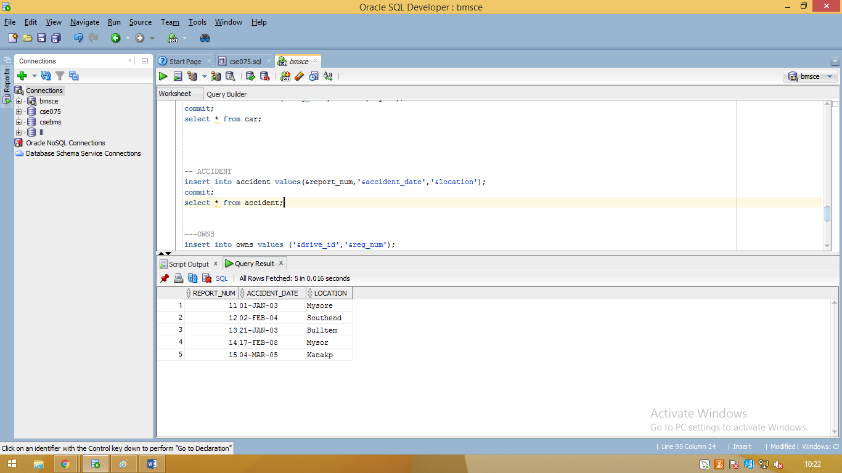

---OWNS

insert into owns values ('&drive_id','&reg_num');

commit;

select * from owns;

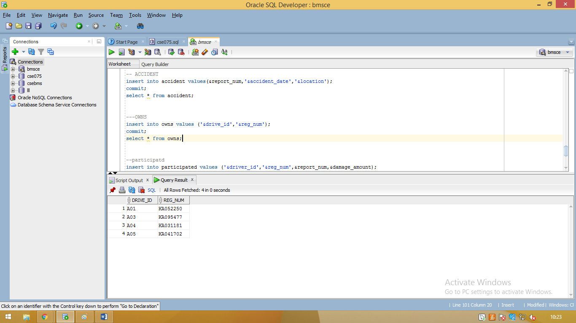

--participatd

insert into participated values ('&driver_id','&reg_num',&report_num,&damage_amount);

commit;

select * from participated;

